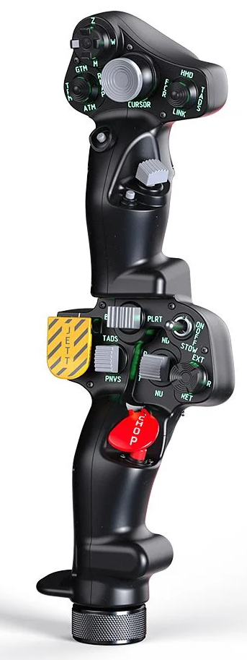  1xx - Controls | 2xx - Ground | 3xx - Flight | 4xx - A2A | 5xx - A2G | 6xx - Misc
102 - Controls - Pilot - Collective Grip Apache-64
U=Up, D=Down, F=Forward, B=Backward, L=Left, R=Right, P=Press, S-*=Shift-*, L-*=Long-*

Top Trigger
- P: Button 19
FCR Scan hat (4-way + push)
- U: Button 3
- D: Button 5
- L: Button 6
- R: Button 4
- P: Button 2
FCR Mode hat (4-way + push)
- U: Button 8
- D: Button 10
- L: Button 11
- R: Button 9
- P: Button 7
Cursor hat (Ministick)
- Axes: X Rotation, Y Rotation
- P: Button 12
Sight Select hat (4-way + push)
- U: Button 14
- D: Button 16
- L: Button 17
- R: Button 15
- P: Button 13
Cursor Select button
- P: Button 18
Cued Search button
- P: Button 20
FCR Transmit hat (2-way spring return + push)
- F: Button 22
- P: Button 21
- B: Button 23
Top Pinky button
- P: Button 24
-------------------------------------------------------------------------------------------------------------------------------------
Bottom trigger
- P: Button 42
Boresight rocker (2-way spring return + push)
- L: Button 27
- P: Button 25
- R: Button 26
Searchlight switch (2-way spring return)
- F: Button 28
- B: Button 29
- B and Hold: Button 29 + Button 45
Searchlight hat (4-way + push)
- U: Button 31
- D: Button 33
- L: Button 34
- R: Button 32
- P: Button 30
Jettison button
- P: Button 35
- P and Hold: Button 35 + Button 46
NVS switch (2-way spring return + push)
- F: Button 37
- P: Button 36
- B: Button 38
Stabilator switch (2-way spring return + push)
- F: Button 40
- P: Button 39
- B: Button 41
Chop button
- P: Button 43
- P and Hold: Button 43 + Button 47
Bottom Pinky button
- P: Button 44
-------------------------------------------------------------------------------------------------------------------------------------
Twist grip idle cut off button:
- P: Button 1
Collective up/down
- Axis: X Axis

